8S - Temperature Card (3hr)

The 8S app allows you to control the temperature of the Pod and set a schedule based on each of your sleep phases (Bedtime, Night, and Dawn).

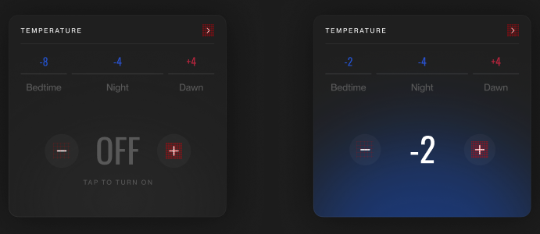

Instructions

- Download the starter project here in the google drive folder
- Build the temperature card described here. The password is 8Sleep
- Temperature color assets are included in the project in the xcassets.

Requirements

- Build the card to match the figma designs
- Phases should be selectable when the card is “On”
- Tapping the -/+ buttons when the card is on should modify the appropriate phase. These changes (temperature changes, power on/off) should display immediately to the user, but must sync to the BE (mocked for you) and eventually be consistent. We can assume the mocked BE never fails an update.
- Tapping the -/+ buttons when the card is off is a no-op

Nice to haves
- Any animations that make the experience delightful
- Fonts are provided but are not required (only if time permits).

What will be assessed
- General code quality
- Attention to detail
- Edge case handling
- Visual consistency when interacting with the card

